The purpose of this website is to showcase my ability to use HTML, CSS, JavaScript and PHP. I made this website to promote the “A dog’s life” to show the services it provides and it’s facilities, by adding different features and improving functionality by allowing the website to communicate with the server.

I chose “A dog’s life” theme because I love animals and had various dogs in the past, I was not a fan of doing other provided themes and this one felt right, I knew spend a lot of time on this theme and learn as I go.

The following are the sketches of some of the pages from the website.

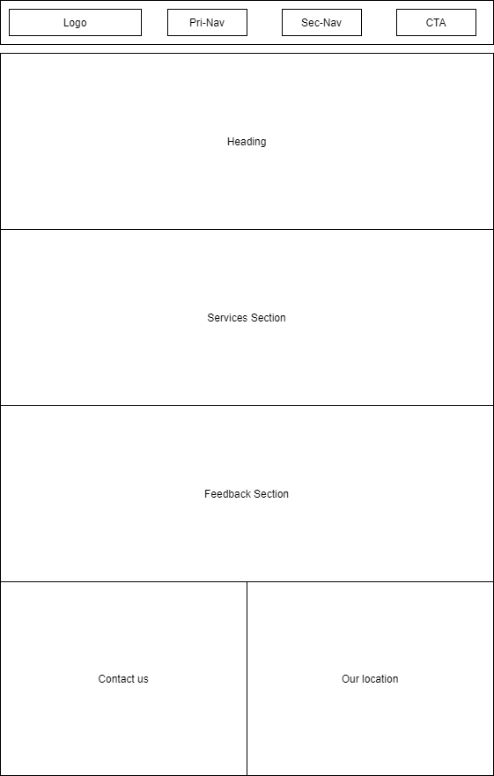

Figure 1. Sketch of the Home page

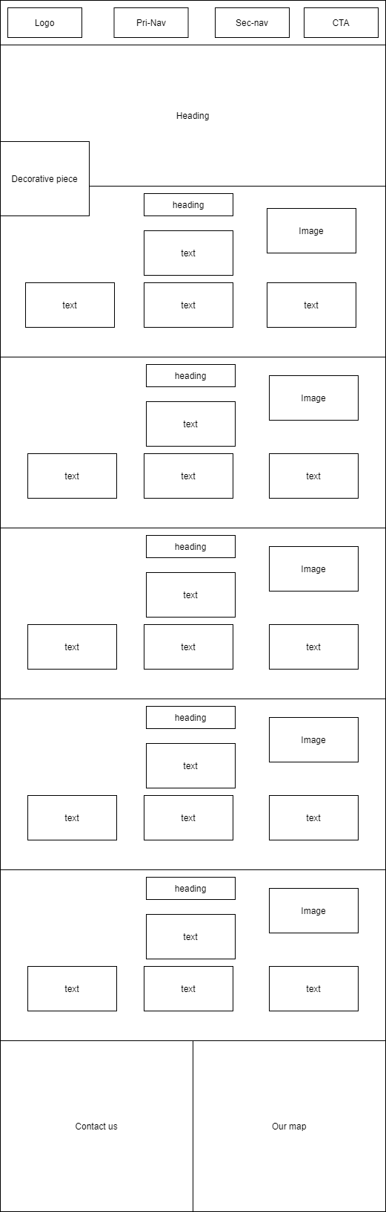

Figure 2. Sketch of the Services page

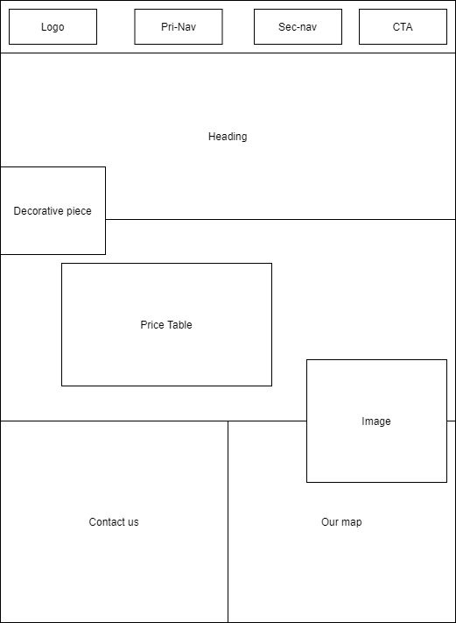

Figure 3. Sketch of the Pricing page

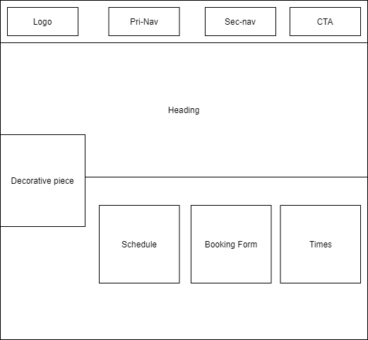

Figure 4. Sketch of the Booking page

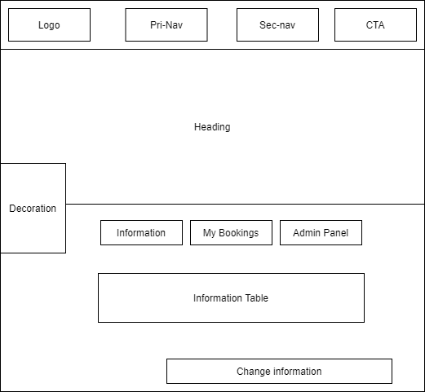

Figure 5. Sketch of the Account Info page

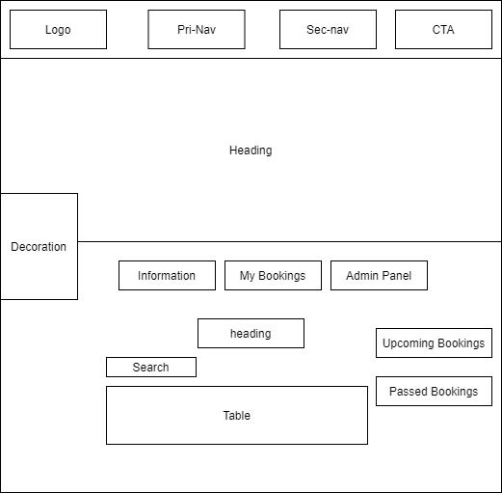

Figure 5. Sketch of the Account Bookings page